Student Demographics per year/per study phase 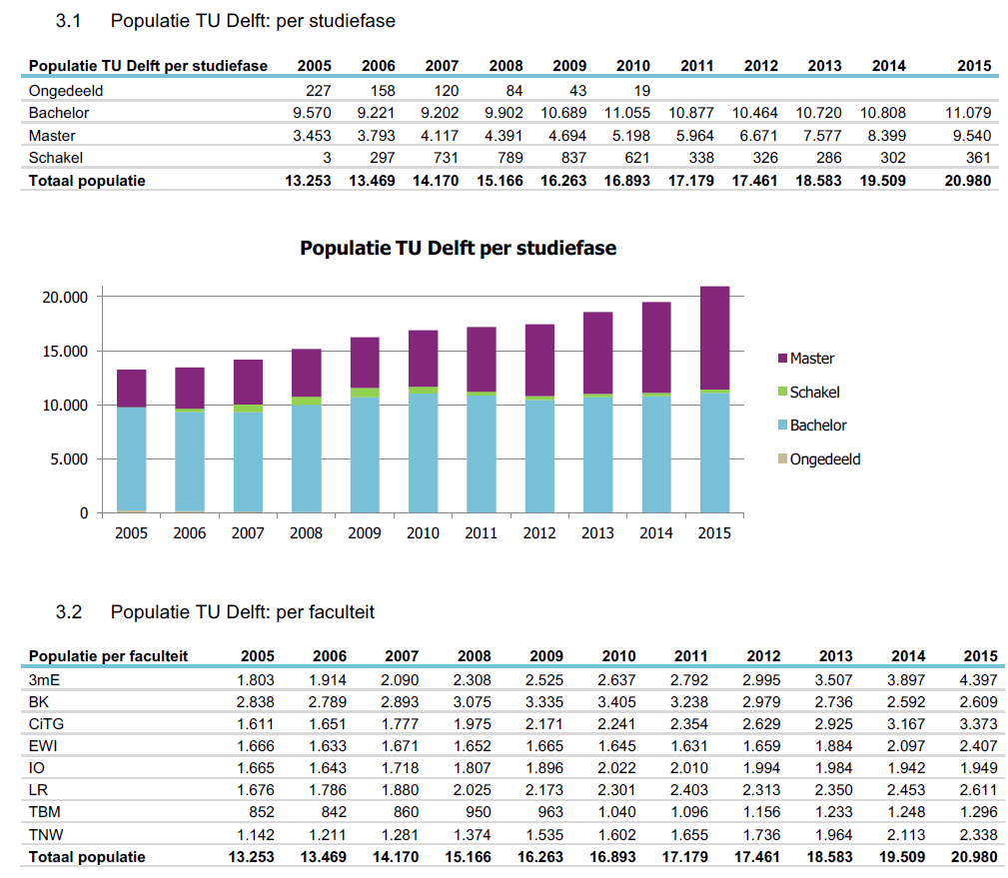
There seems to have been an increase in students. We see an increase in the amount of master track students. (Is this because of the bump in the bachelor track of 2007 - 2010?)

International Students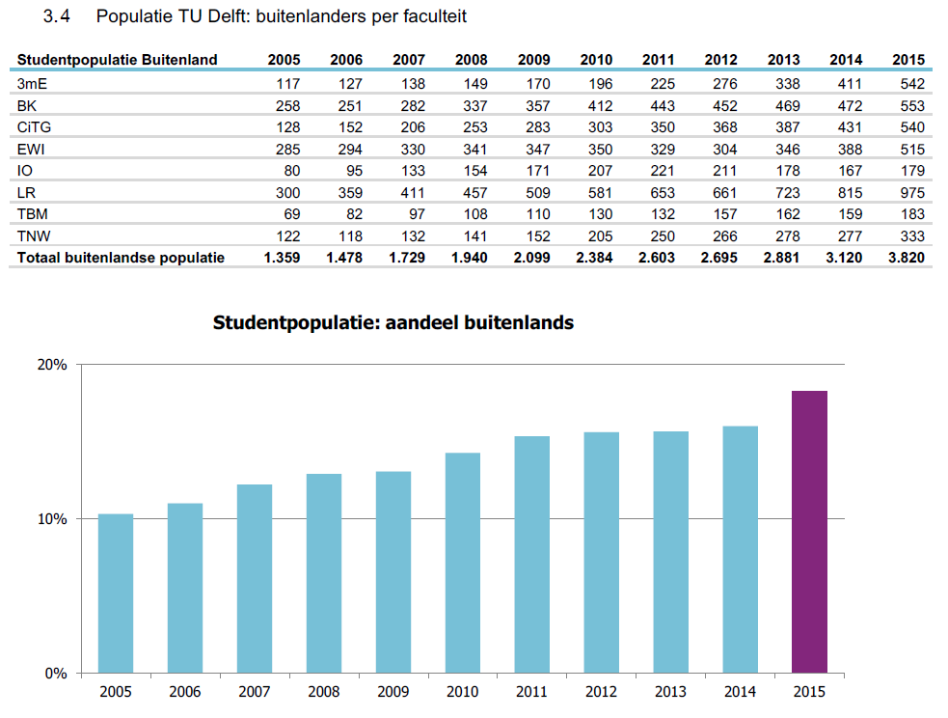
We also see an increase in the number of international students. 2015 seems to have had the biggest increase. (does this account for the increase in master students? Still not all bachelor tracks are in English)

TU-Delft Staff
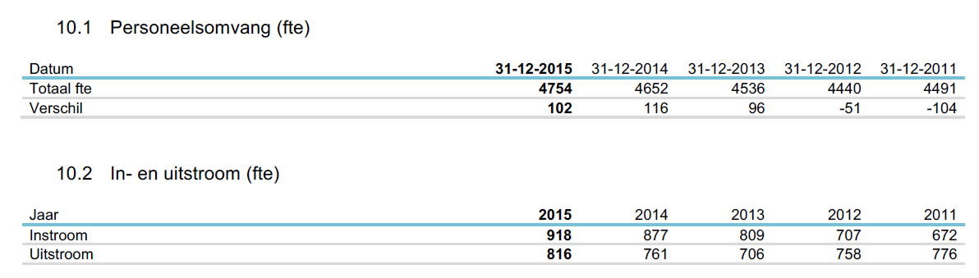
In the years after 2012 staff is increasing. Outflux of staff increased as well. People work temporarily at TU Delft.

Faculty bound staff
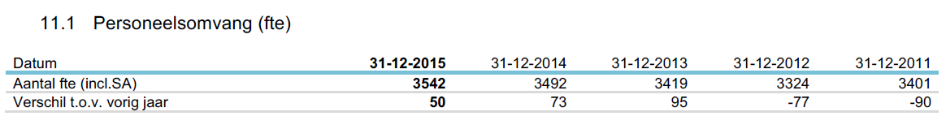

Faculty bound staff (permanent/temporary)
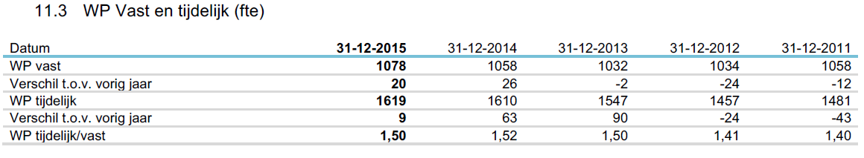
There is 50% more temporary working staff than permanent staff. This seems to have increased in the last couple years.

Staff by function (permanent)
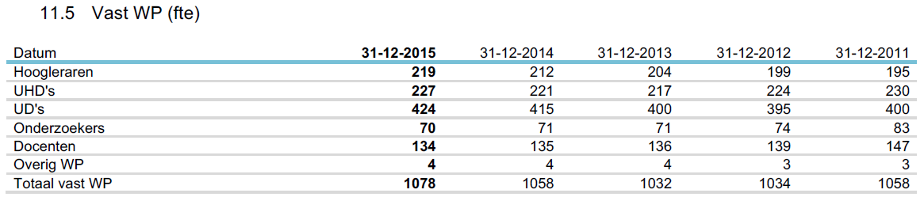

Staff by function (temporary)
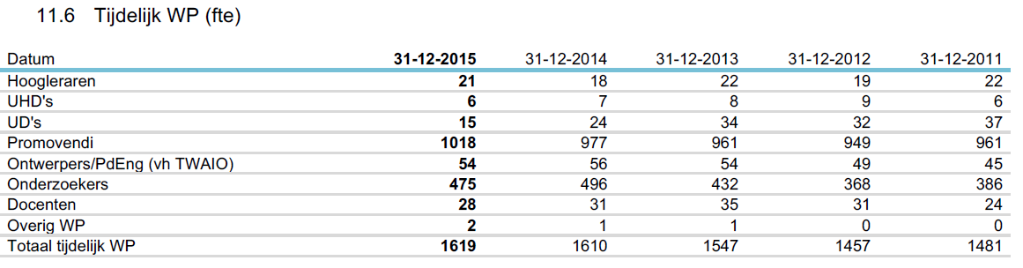
We see increases in PhD. students and researchers.

Employees
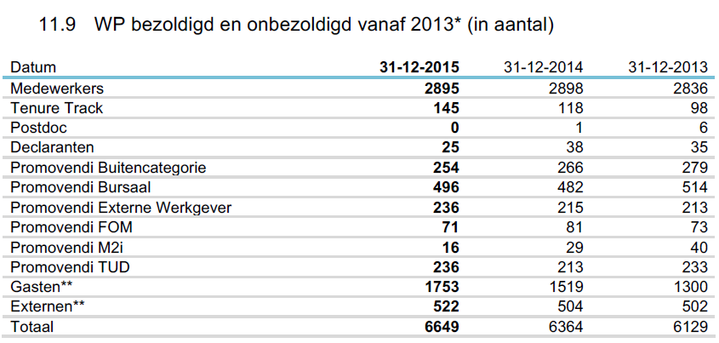
Guest employees seems to have the biggest increase in numbers, adding more than 200 people each year.

“Student blijft thuis wonen door leenstelsel”
More students decide to continue living at their parents because of discontinuation of basic student grants. Delft is one of the cities that notices this the most.
http://www.trouw.nl/tr/nl/39683/nbsp/article/detail/4376920/2016/09/15/Student-blijft-thuis-wonen-door-leenstelsel.dhtml

Recap
Looking back at the numbers given by the TU-Delft we see a general increase in student- and employee-population. For students we see an increase in the number of Master-track followers. This increase seems to stand parallel to the increase in number of international students that study at the TU-Delft, with 2015 having the biggest increase in the last 10 years.
Influx of TU-Delft employees is increasing but the outflux as well. Would this mean that these people work mostly temporarily or is it a simple fifo (first one in, first one out) principle that is happening. The numbers tell us that most of the faculty bound employees at the TU-Delft are temporary. We find a large number of them working as PhD. students and researchers. For every researcher there are two PhD. students. We can also find an increasing number of people getting invited to the TU-Delft; guests. Up until 2013 the TU-Delft has added another 200 guest per year to the amount of guest it had the year before.
Although we see an increase of students and employees we also have to take into account the socio-cultural context of the Netherlands. Since 2015 Dutch students don’t get a basic student grant for their higher education. This grant-model changed into a loan-model. This resulted in students staying at their parents to save money.

Conclusion
Based on the numbers we can conclude that the increase in students and the TU-Delft employees calls for more housing. Since Dutch students increasingly tend to stay at their parent’s place, the focus for housing shifts towards international students and temporary employees. The majority of these temporary employees are PhD. students and researchers.
The time it takes PhD students to finish their research is at least 4 years. The time it takes International students to finish their (master)- track is at least 2 years. But can we assume all international students only follow the full master programs that TU-Delft offers? What about exchange students and international bachelor students?

